1. SELECT Fname FROM employee, works_on, project WHERE ssn = Essn AND Dno = Dnum AND Pname = "ProductX" AND Pno = Pnumber;

https://i.imgur.com/GYs5RfM.png

1. SELECT Fname FROM employee, dependent WHERE Dependent_name = Fname;

https://i.imgur.com/svzgHh4.png

1. SELECT Fname FROM employee WHERE Super_ssn IN (SELECT Mgr_ssn FROM department, employee WHERE Fname = "Franklin" AND Lname = "Wong" AND Mgr_ssn = Ssn);

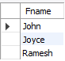

1. SELECT Pname, Sum(Hours) FROM project, works_on WHERE Pno = Pnumber GROUP BY Pnumber;

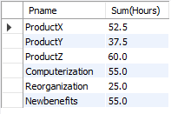

1. SELECT Fname from employee WHERE Ssn IN (SELECT DISTINCT Essn FROM works_on WHERE Pno IN (SELECT Pno FROM client WHERE Cname = "JPL"));

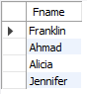

1. SELECT Fname from employee WHERE Ssn NOT IN (SELECT DISTINCT Essn FROM works_on WHERE Pno IN (SELECT Pno FROM client WHERE Cname = "JPL"));

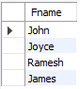

1. SELECT Dname, avg(Salary) FROM department, employee WHERE Dno = Dnumber GROUP BY Dno;

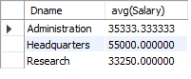

1. SELECT sum(hours) / count(DISTINCT Essn) FROM works_on WHERE Essn IN (SELECT ssn FROM employee WHERE sex = "F");

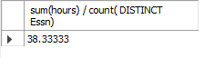

1. SELECT Fname, Address FROM employee WHERE Ssn IN ( SELECT Essn FROM works_on WHERE Pno IN (SELECT Pnumber FROM project WHERE Plocation = "Houston")) AND Dno NOT IN (SELECT Dnumber FROM dept_locations WHERE Dlocation = "Houston");

https://i.imgur.com/xRfw7WT.png

1. SELECT Lname FROM employee WHERE Ssn IN (SELECT Mgr_ssn FROM department WHERE Mgr_ssn NOT IN (SELECT Essn FROM dependent));

https://i.imgur.com/jefPyll.png